Cyber Risk Assessment & Threat Intelligence Platform

Abstract
This project presents a Cyber Risk Assessment and Threat Intelligence Platform developed using Python, Flask, and Streamlit. The system scans target systems to detect open ports, identifies vulnerabilities, assigns risk scores, and integrates external threat intelligence using the VirusTotal API. The results are stored in a centralized SQLite database and visualized through interactive dashboards. The platform helps organizations quickly identify security risks and take preventive actions.

Introduction
With increasing cyber threats, organizations need automated tools to monitor vulnerabilities and risks. Manual security analysis is time-consuming and error-prone.
This project provides:
- Automated port scanning
- Vulnerability detection
- Risk scoring system
- Threat intelligence integration
- Visualization dashboard
It combines network scanning + intelligence APIs + analytics into one platform.

Objectives
- Detect open ports using scanning tools
- Identify vulnerabilities based on ports
- Assign risk scores automatically
- Store scan results in database
- Integrate VirusTotal API for threat intelligence
- Provide dashboards for visualization
- Generate reports for analysis

Problem Statement
- Lack of simple tools for real-time cyber risk assessment
- Difficulty in combining:
  - Port scanning
  - Vulnerability analysis
  - Threat intelligence
- No centralized system for risk visualization
- Manual analysis leads to delays and errors

Proposed Solution
The system works in the following flow:
- User enters target IP/domain
- Port scanner detects open ports
- Vulnerability scanner maps risks
- Risk engine assigns scores
- Data is stored in SQLite database
- Threat API provides external intelligence
- Results displayed in dashboard

System Architecture
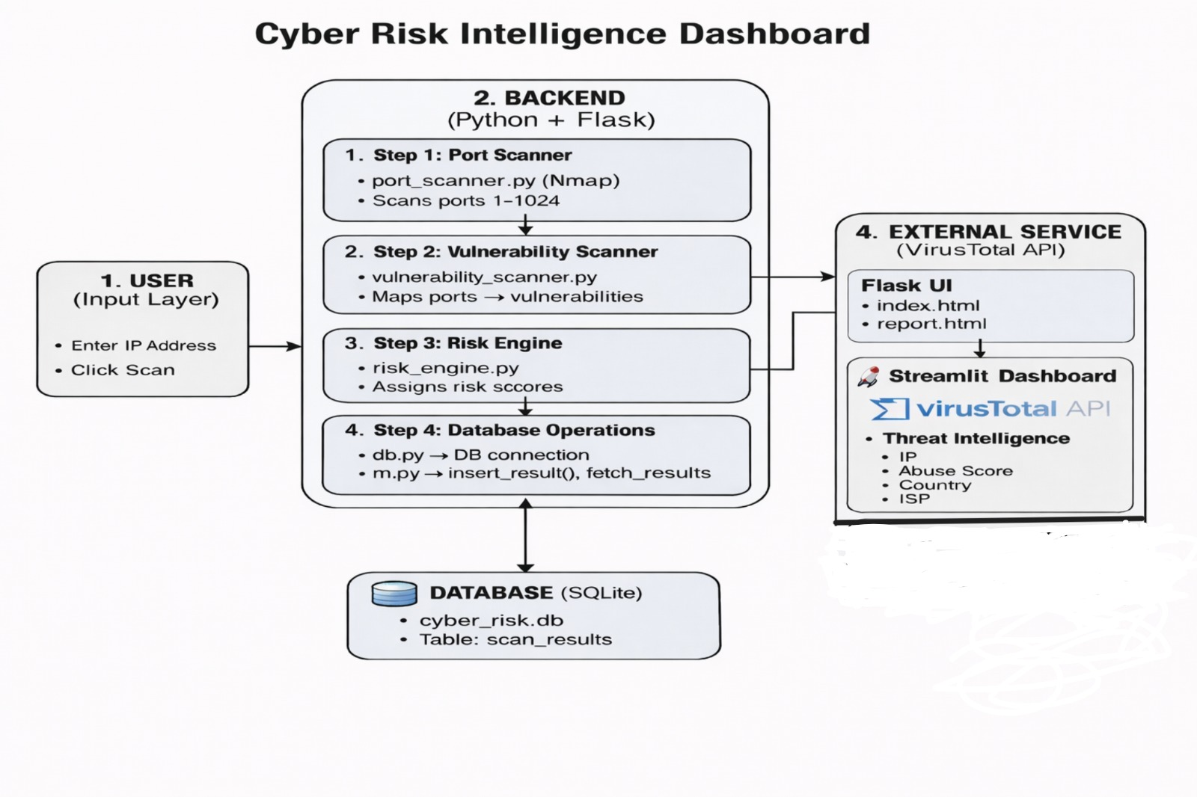

Implementation
🔹 Backend
- Python (Flask framework)
- Handles requests and responses
- Controls scanning workflow
- Integrates all modules
🔸 Modules
- Port Scanner
  - Uses Nmap
  - Scans ports (1–1024)
- Vulnerability Scanner
  - Maps ports to known issues

- Risk Engine
  - Assigns scores:
    - High (9)
    - Medium (7)
    - Low (5)
🔸 Database (SQLite)
- File: cyber_risk.db
- Table: scan_results
- Stores:
  - Port
  - Issue
  - Risk score
🔸 Frontend
- Flask HTML dashboard
- Streamlit advanced dashboard
- Charts using Chart.js / Plotly
🔸 Threat Intelligence
- VirusTotal API
- Provides:
  - Abuse score
  - Country
  - ISP

Results

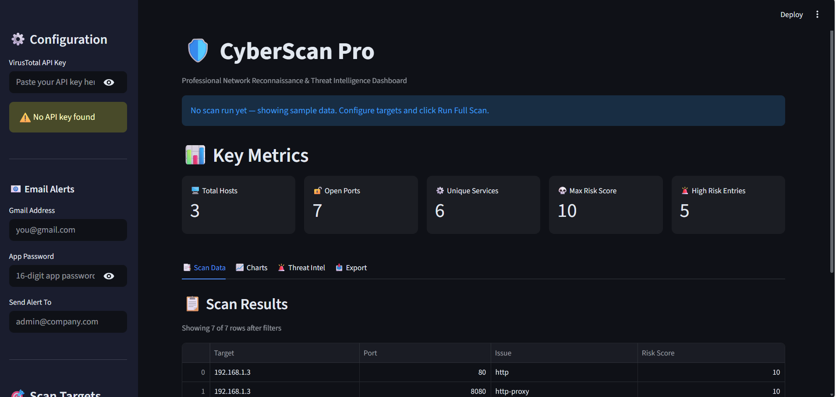

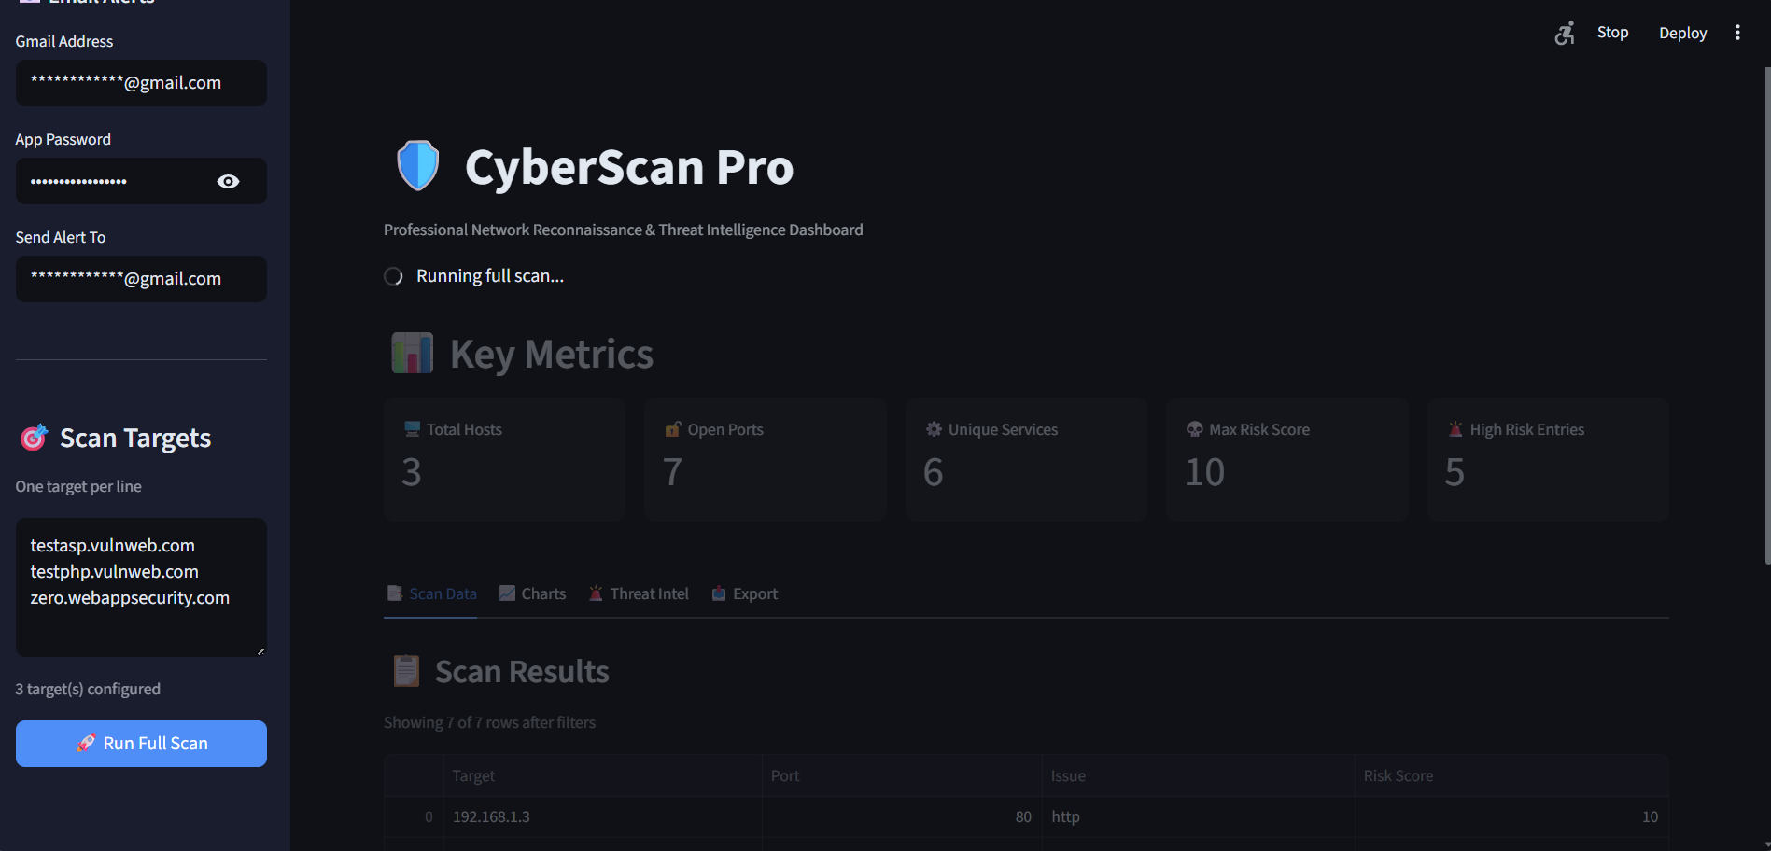

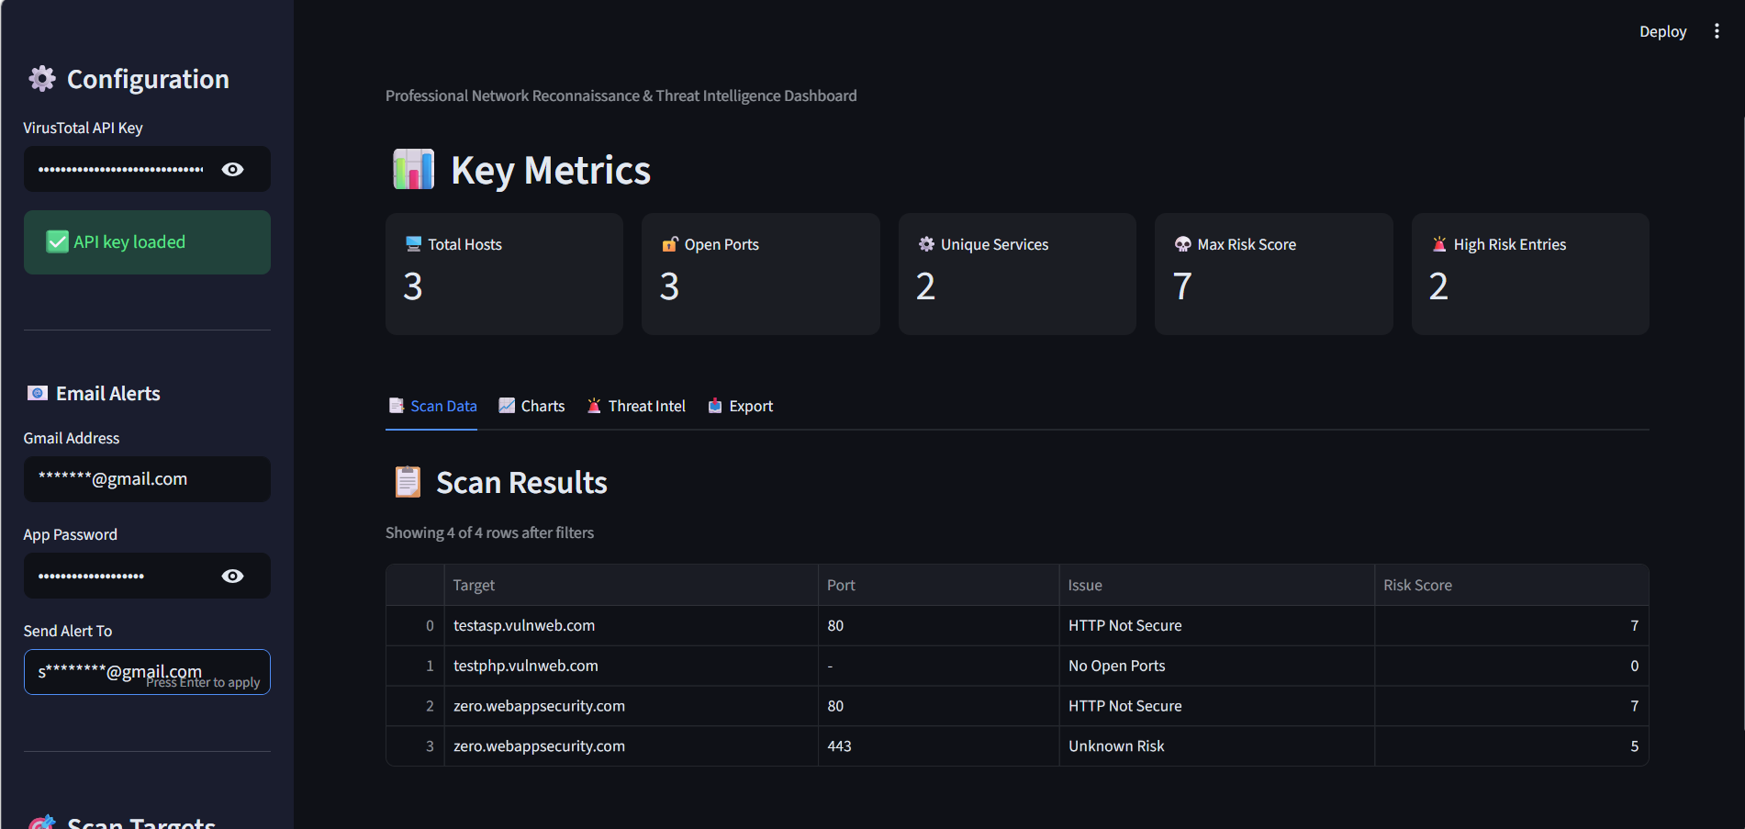

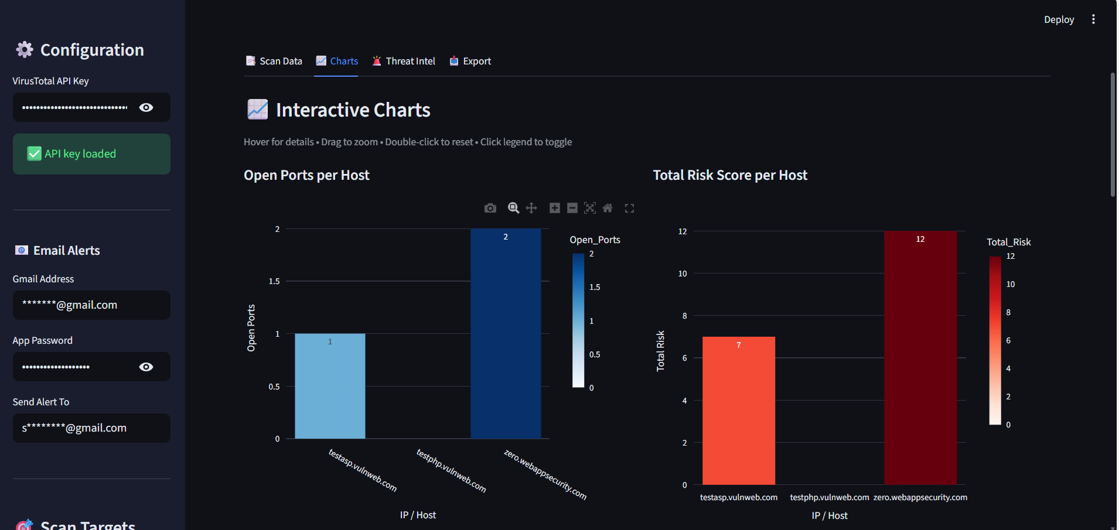

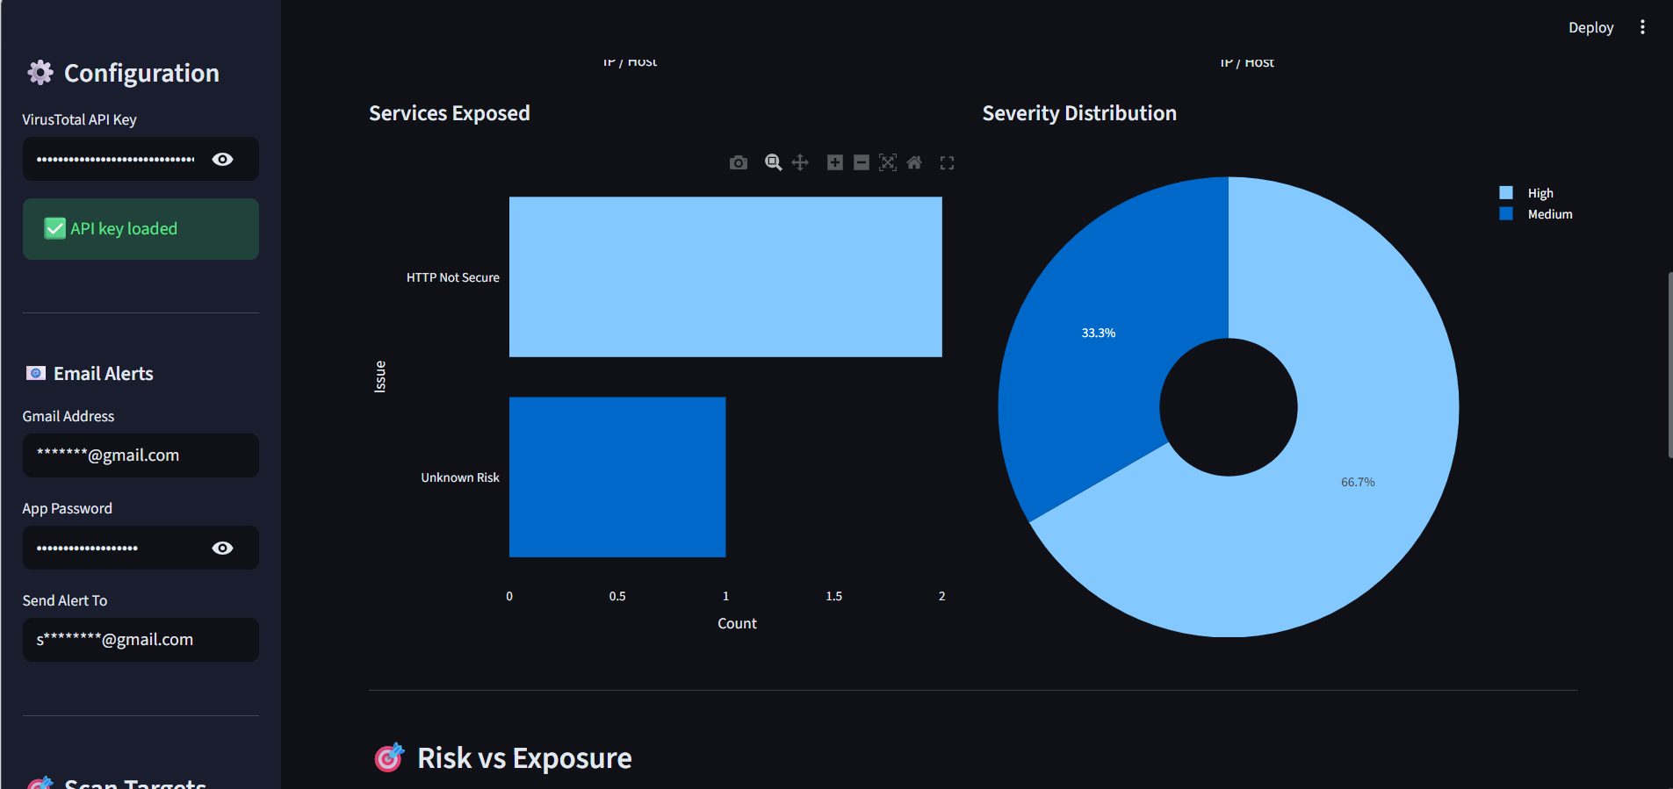

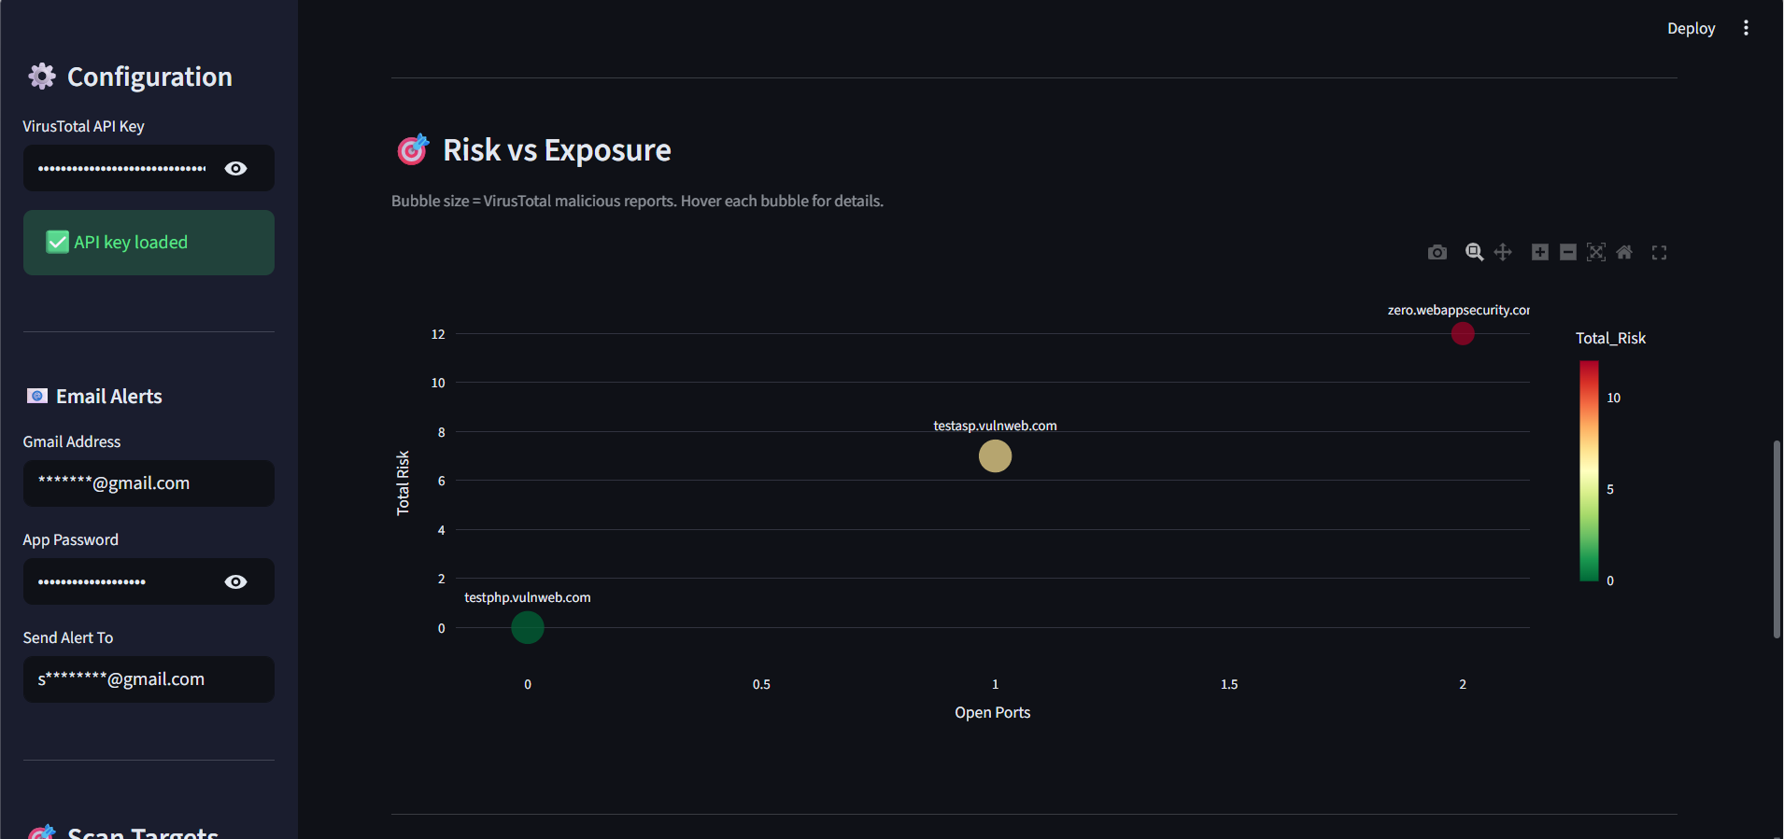

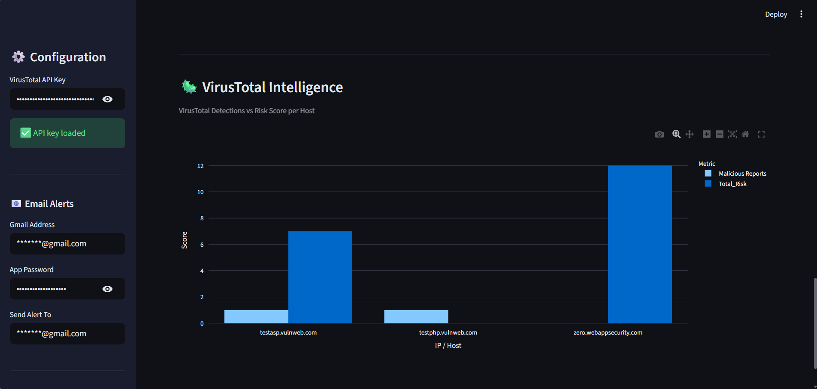

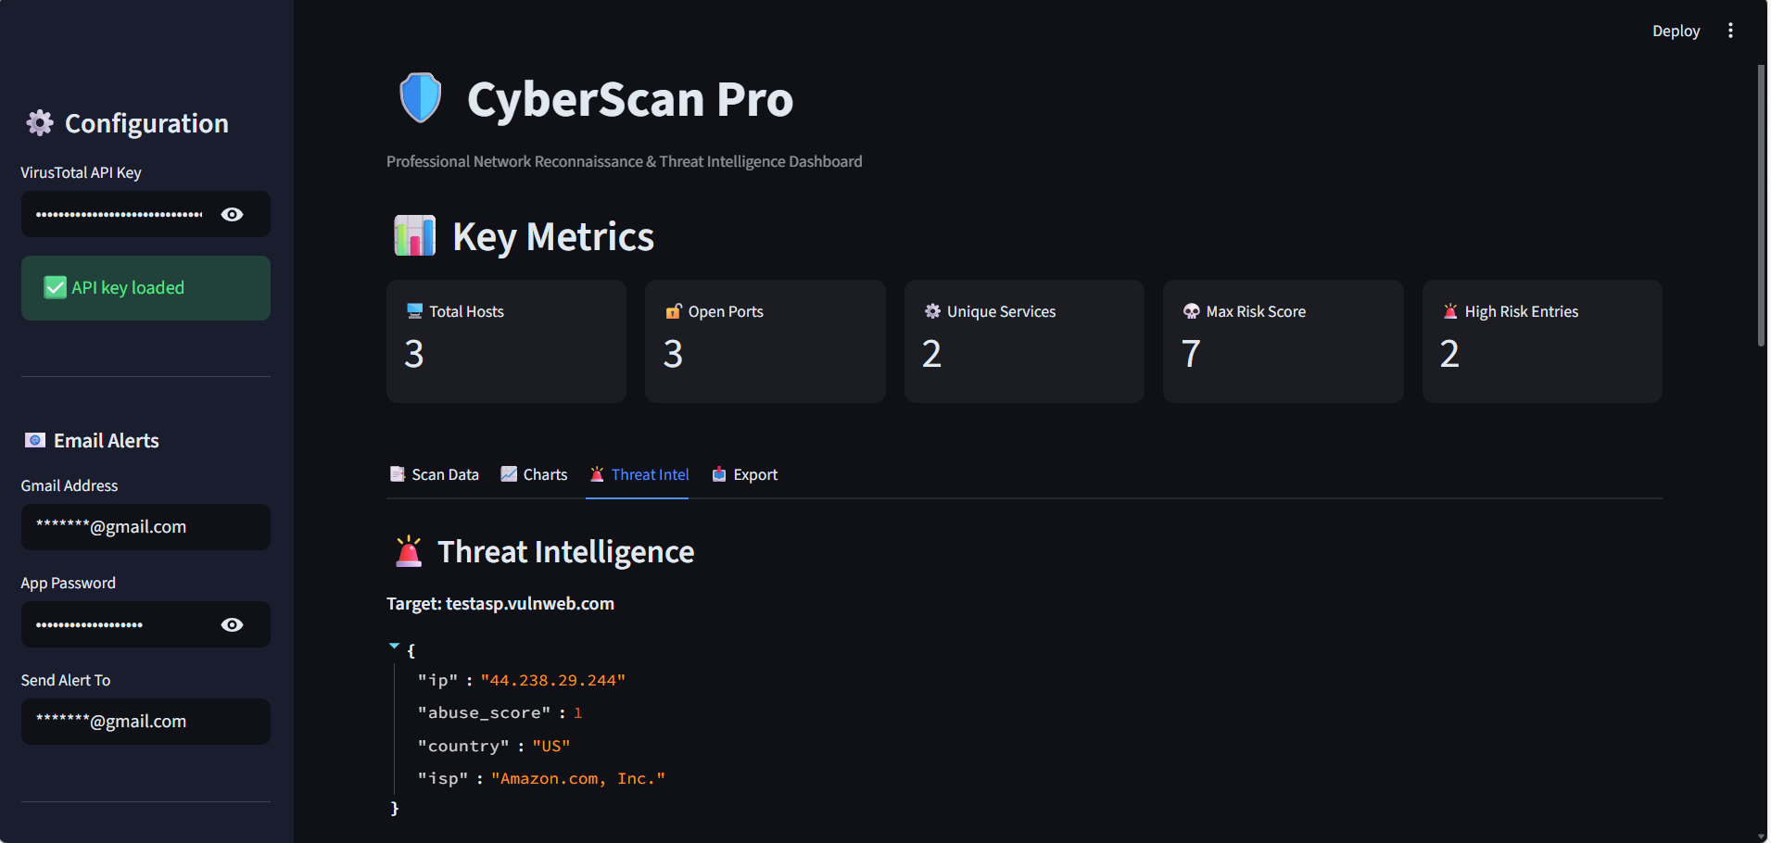

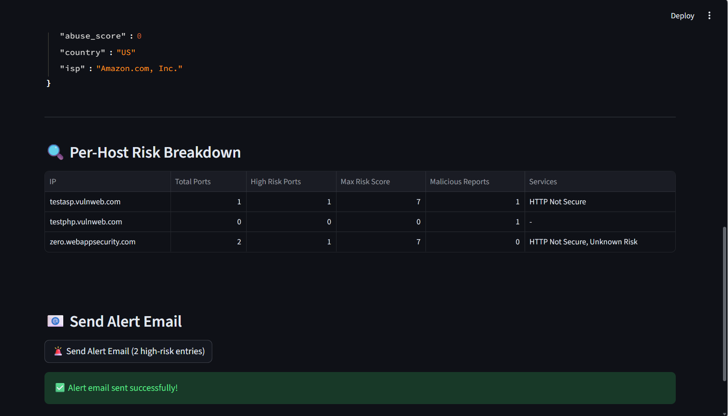

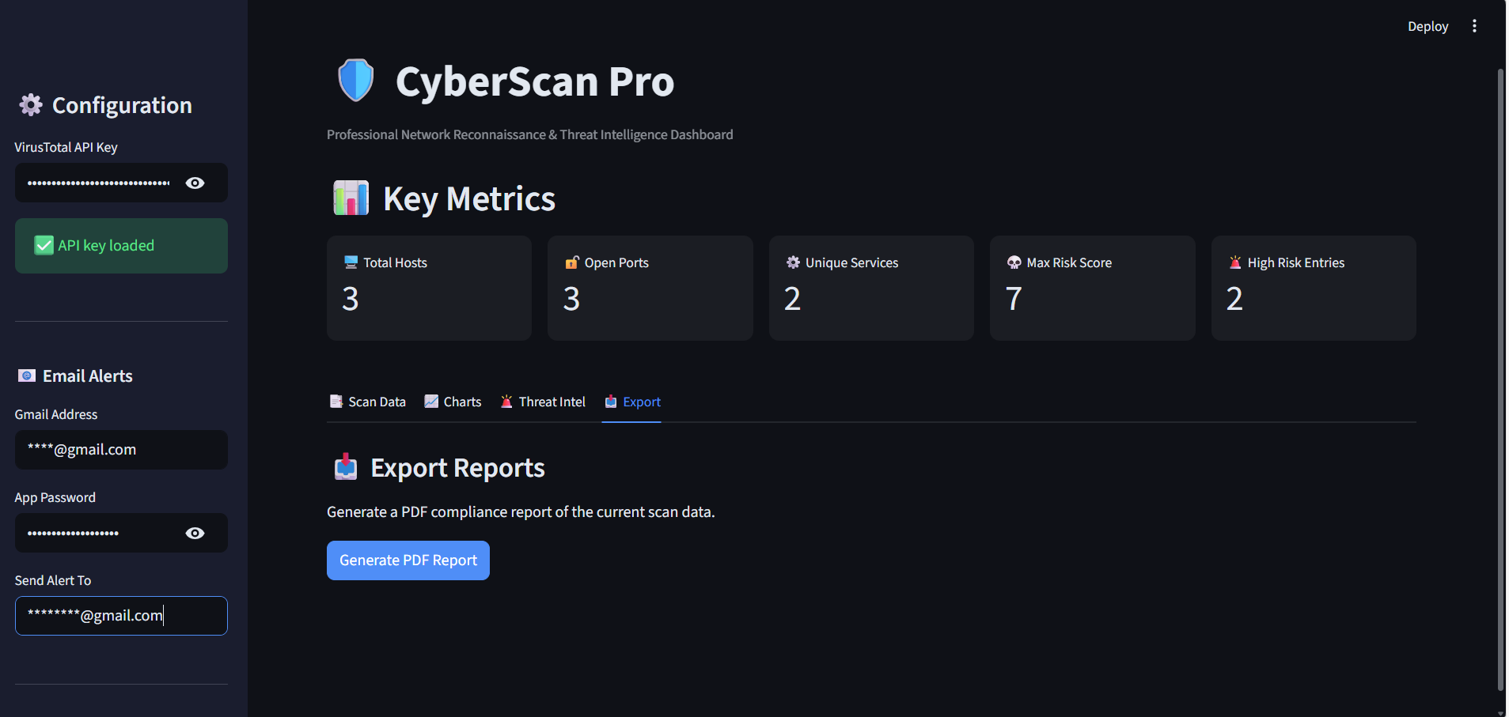

Challenges and Learnings
🔸 Challenges
- Integrating Nmap with Python
- Handling API errors (VirusTotal)
- Managing database operations
- Designing dashboard UI
🔸 Learnings
- Flask backend development
- API integration
- Cybersecurity basics
- Data visualization
- Full-stack project architecture

Future Scope
- Add real-time monitoring system
- Integrate more APIs (Shodan, Nessus)
- Use AI for risk prediction
- Deploy on cloud platform
- Add user authentication system
- Improve vulnerability database

Conclusion
The project successfully demonstrates a complete cyber risk assessment system combining scanning, analysis, and visualization. It simplifies security analysis and helps identify risks quickly. The platform can be extended into a full enterprise-level security tool.
Presented By
SP Keerthi

